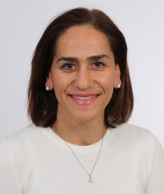

Medine C. YILMAZ, RN, Ph.D, Prof.
Professor Medine Yilmaz completed her Bachelor of Science (B.S.) and Master of Science (M.S) in Nursing, İstanbul University Florence Nightingale Nursing School, Istanbul, Turkey. In 2006, she received her Ph.D. Nursing. She worked a head nurse at the Pediatric Oncology and Stem Cell Transplantation Unit, Ege University Medical Faculty Hospital, Izmir between 2011 and 2012. She has been worked in Izmir Katip Çelebi University, Faculty of Health Sciences, Nursing Department as an academician nurse since October 2012. Prof. Yilmaz has published articles on pediatric oncology nursing, stem cell transplantation, and home care in Turkish and English. She has edited two books in Turkish (Home Care Nursing- https://www.nobelkitabevi.com.tr/hemsirelik-dahiliye/17301-evde-bakim-hemsireligi-9786052586969.html) and Pediatric Oncology Nursing) (https://onkohem.org.tr/arsiv/2045). Since 2006, she has been actively involved as an organizer and speaker in the organization of the nursing sessions of the congresses of the Turkish Pediatric Oncology Association. In addition since 2017, she support the organization of European Hematology-Oncology Congress Nursing Programme. She is a member of the Turkish Oncology Nurses Association and a working member of the pediatric subgroup. Her research interests are symptom management, oral care, child health, home care nursing and nursing education.

